HACKER RANK – SQL QUESTIONS
BASIC SELECT
1. Query all columns for all American cities in CITY with populations larger than 100000. The CountryCode for America is USA.
Input Format
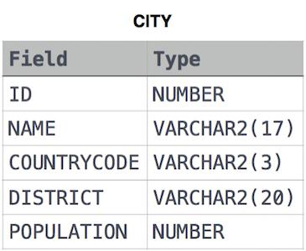
the CITY table is described as follows:
ANS:-
select * from city
where POPULATION > 100000 and
COUNTRYCODE = 'USA';
2. Query the names of all American cities in CITY with populations larger than 120000. The CountryCode for America is USA.
Input Format

The CITY table is described as follows:
ANS:-
SELECT NAME FROM CITY
WHERE POPULATION >120000 AND COUNTRYCODE = 'USA';
3. Query all columns (attributes) for every row in the CITY table.
Input Format

The CITY table is described as follows:
ANS:- SELECT * FROM CITY;
4. Query all columns for a city in CITY with the ID 1661.
Input Format

The CITY table is described as follows:
ANS:- SELECT * FROM CITY
WHERE ID = 1661;
5. Query all attributes of every Japanese city in the CITY table. The COUNTRYCODE for Japan is JPN.
Input Format

The CITY table is described as follows:
ANS:-
SELECT * FROM CITY
WHERE COUNTRYCODE = 'JPN';
6. Query a list of CITY and STATE from the STATION table.
Input Format
The STATION table is described as follows:
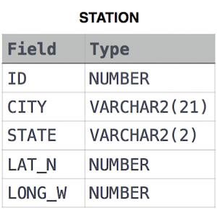
where LAT_N is the northern latitude and LONG_W is the western longitude.
ANS:- SELECT CITY,STATE FROM STATION ;
7. Query a list of CITY names from STATION with even ID numbers only. You may print the results in any order, but must exclude duplicates from your answer.
Input Format
The STATION table is described as follows:

where LAT_N is the northern latitude and LONG_W is the western longitude.
ANS:-
SELECT DISTINCT CITY FROM STATION
WHERE ID % 2 = 0;
8. Let N be the number of CITY entries in STATION, and let be the number of distinct CITY names in STATION; query the value of N-N’from STATION. In other words, find the difference between the total number of CITY entries in the table and the number of distinct CITY entries in the table.
Input Format
The STATION table is described as follows:

where LAT_N is the northern latitude and LONG_W is the western longitude.
ANS:-
SELECT COUNT(CITY)-COUNT(DISTINCT CITY) FROM STATION;
9. Query the two cities in STATION with the shortest and longest CITY names, as well as their respective lengths (i.e.: number of characters in the name). If there is more than one smallest or largest city, choose the one that comes first when ordered alphabetically.
Input Format
The STATION table is described as follows:

where LAT_N is the northern latitude and LONG_W is the western longitude.
Sample Input
Let's say that CITY only has four entries: DEF, ABC, PQRS and WXY
Sample Output
ABC 3
PQRS 4
ANS:-
SELECT CITY , LENGTH(CITY) AS LENG FROM STATION
ORDER BY LENG ASC , CITY ASC LIMIT 1;
SELECT CITY,LENGTH(CITY) AS LENG FROM STATION
ORDER BY LENG DESC,CITY DESC LIMIT 1;
10. Query the list of CITY names starting with vowels (i.e., a, e, i, o, or u) from STATION. Your result cannot contain duplicates.
Input Format
The STATION table is described as follows:

where LAT_N is the northern latitude and LONG_W is the western longitude.
ANS:-
SELECT CITY FROM STATION
WHERE CITY REGEXP '^[aeiou]';
11. Query the list of CITY names ending with vowels (a, e, i, o, u) from STATION. Your result cannot contain duplicates.
Input Format
The STATION table is described as follows:

where LAT_N is the northern latitude and LONG_W is the western longitude.
ANS:-
SELECT DISTINCT CITY FROM STATION
WHERE CITY LIKE '%a'
OR CITY LIKE '%e'
OR CITY LIKE '%i'
OR CITY LIKE '%o'
OR CITY LIKE '%u';
12. Query the list of CITY names from STATION which have vowels (i.e., a, e, i, o, and u) as both their first and last characters. Your result cannot contain duplicates.
Input Format
The STATION table is described as follows:

where LAT_N is the northern latitude and LONG_W is the western longitude.
ANS:-
SELECT DISTINCT CITY FROM STATION
WHERE (CITY LIKE 'a%'
OR CITY LIKE 'e%'
OR CITY LIKE 'i%'
OR CITY LIKE 'o%'
OR CITY LIKE 'u%')AND
(CITY LIKE '%a'
OR CITY LIKE '%e'
OR CITY LIKE '%i'
OR CITY LIKE '%o'
OR CITY LIKE '%u');
13. Query the list of CITY names from STATION that do not start with vowels. Your result cannot contain duplicates.
Input Format
The STATION table is described as follows:

where LAT_N is the northern latitude and LONG_W is the western longitude.
ANS:-
SELECT DISTINCT CITY FROM STATION
WHERE CITY REGEXP '^[^aeiou]';
14. Query the list of CITY names from STATION that do not end with vowels. Your result cannot contain duplicates.
Input Format
The STATION table is described as follows:

where LAT_N is the northern latitude and LONG_W is the western longitude.
ANS:-
SELECT DISTINCT CITY FROM STATION
WHERE CITY NOT LIKE '%a'
AND CITY NOT LIKE '%e'
AND CITY NOT LIKE '%i'
AND CITY NOT LIKE '%o'
AND CITY NOT LIKE '%u';
15. Query the list of CITY names from STATION that either do not start with vowels or do not end with vowels. Your result cannot contain duplicates.
Input Format
The STATION table is described as follows:

where LAT_N is the northern latitude and LONG_W is the western longitude.
ANS:-
SELECT DISTINCT CITY FROM STATION
WHERE (CITY NOT LIKE 'a%'
AND CITY NOT LIKE 'e%'
AND CITY NOT LIKE 'i%'
AND CITY NOT LIKE 'o%'
AND CITY NOT LIKE 'u%')
or (CITY NOT LIKE '%a'
AND CITY NOT LIKE '%e'
AND CITY NOT LIKE '%i'
AND CITY NOT LIKE '%o'
AND CITY NOT LIKE '%u');
16. Query the list of CITY names from STATION that do not start with vowels and do not end with vowels. Your result cannot contain duplicates.
Input Format

The STATION table is described as follows:
where LAT_N is the northern latitude and LONG_W is the western longitude.
ANS:-
SELECT DISTINCT CITY FROM STATION
WHERE CITY NOT LIKE 'a%'
AND CITY NOT LIKE 'e%'
AND CITY NOT LIKE 'i%'
AND CITY NOT LIKE 'o%'
AND CITY NOT LIKE 'u%'
AND CITY NOT LIKE '%a'
AND CITY NOT LIKE '%e'
AND CITY NOT LIKE '%i'
AND CITY NOT LIKE '%o'
AND CITY NOT LIKE '%u';
17. Query the Name of any student in STUDENTS who scored higher than 75 Marks. Order your output by the last three characters of each name. If two or more students both have names ending in the same last three characters (i.e.: Bobby, Robby, etc.), secondary sort them by ascending ID.
Input Format

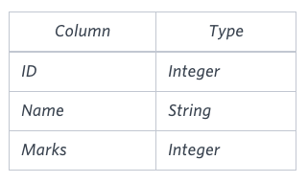
The STUDENTS table is described as follows:
The Name column only contains uppercase (A-Z) and lowercase (a-z) letters.
Sample Input
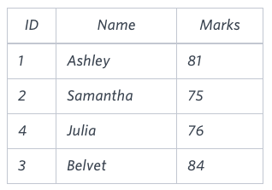
Sample Output
Ashley
Julia
Belvet
Explanation
Only Ashley, Julia, and Belvet have Marks > 75. If you look at the last three characters of each of their names, there are no duplicates and 'ley' < 'lia' < 'vet'.
ANS:-
SELECT NAME FROM STUDENTS
WHERE MARKS > 75
ORDER BY RIGHT(NAME,3),ID ASC;
18. Write a query that prints a list of employee names (i.e.: the name attribute) from the Employee table in alphabetical order.
Input Format
The Employee table containing employee data for a company is described as follows:
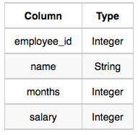
where employee_id is an employee's ID number, name is their name, months is the total number of months they've been working for the company, and salary is their monthly salary.
Sample Input
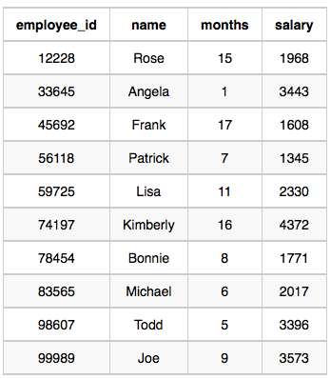
Sample Output
Angela
Bonnie
Frank
Joe
Kimberly
Lisa
Michael
Patrick
Rose
Todd

ANS:-
SELECT NAME FROM EMPLOYEE
ORDER BY NAME ASC;
19. Write a query that prints a list of employee names (i.e.: the name attribute) for employees in Employee having a salary greater than $2000 per month who have been employees for less than 10 months. Sort your result by ascending employee_id.
Input Format
The Employee table containing employee data for a company is described as follows:

where employee_id is an employee's ID number, name is their name, months is the total number of months they've been working for the company, and salary is the their monthly salary.
Sample Input

Sample Output
Angela
Michael
Todd
Joe
Explanation
Angela has been an employee for 1 month and earns $3443 per month.
Michael has been an employee for 6 months and earns $2017 per month.
Todd has been an employee for 5 months and earns $3396 per month.
Joe has been an employee for 9 months and earns $3573 per month.
We order our output by ascending employee_id.
ANS:-
SELECT NAME FROM EMPLOYEE
WHERE SALARY > 2000 AND MONTHS < 10
ORDER BY EMPLOYEE_ID;

ADVANCED SELECT
1.Write a query identifying the type of each record in the TRIANGLES table using its three side lengths. Output one of the following statements for each record in the table:
- Equilateral: It's a triangle with 3 sides of equal length.
- Isosceles: It's a triangle with 2 sides of equal length.
- Scalene: It's a triangle with 3 sides of differing lengths.
- Not A Triangle: The given values of A, B, and C don't form a triangle.
Input Format
The TRIANGLES table is described as follows:
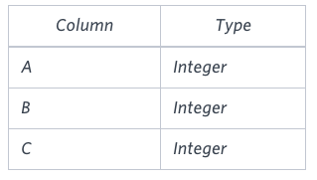
Each row in the table denotes the lengths of each of a triangle's three sides.
Sample Input
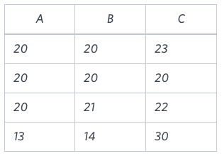
Sample Output
Isosceles
Equilateral
Scalene
Not A Triangle

Explanation
Values in the tuple(20,20,23) form an Isosceles triangle, because A=B .
Values in the tuple(20,20,20) form an Equilateral triangle, because A=B=C . Values in the tuple(20,21,22) form a Scalene triangle, becauseA=/B=/C .
Values in the tuple(13,14,30) cannot form a triangle because the combined value of sides A and B is not larger than that of side C.
ANS:-
SELECT CASE WHEN A + B <= C OR A + C <= B OR B + C <= A THEN 'Not A Triangle'
WHEN A = B AND B = C THEN 'Equilateral'
WHEN (A = B AND B != C) OR (A = C AND C != B) OR (B = C AND C !=A) THEN 'Isosceles'
WHEN A != B AND B != C THEN 'Scalene'
END
FROM TRIANGLES;
2.Generate the following two result sets:
- Query an alphabetically ordered list of all names in OCCUPATIONS, immediately followed by the first letter of each profession as a parenthetical (i.e.: enclosed in parentheses). For example: AnActorName(A), ADoctorName(D), AProfessorName(P), and ASingerName(S).
2. Query the number of ocurrences of each occupation in OCCUPATIONS. Sort the occurrences in ascending order, and output them in the following format:
There are a total of [occupation_count] [occupation]s.
where [occupation_count] is the number of occurrences of an occupation in OCCUPATIONS and [occupation] is the lowercase occupation name. If more than one Occupation has the same [occupation_count], they should be ordered alphabetically.
Note: There will be at least two entries in the table for each type of occupation.
Input Format
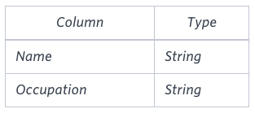
The OCCUPATIONS table is described as follows:
Occupation will only contain one of the following values: Doctor, Professor, Singer or Actor.
Sample Input
An OCCUPATIONS table that contains the following records:
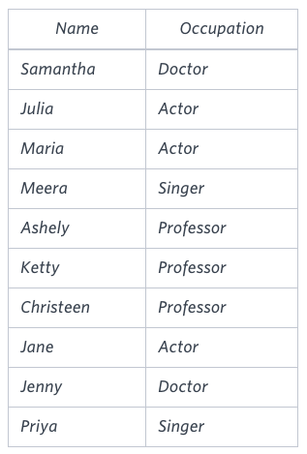
Sample Output
Ashely(P)
Christeen(P)
Jane(A)
Jenny(D)
Julia(A)
Ketty(P)
Maria(A)
Meera(S)
Priya(S)
Samantha(D)
There are a total of 2 doctors.
There are a total of 2 singers.
There are a total of 3 actors.
There are a total of 3 professors.

Explanation
The results of the first query are formatted to the problem description's specifications.
The results of the second query are ascendingly ordered first by number of names corresponding to each profession (2<=2<=3<=3), and then alphabetically by profession (doctor<=singer, and actor<=professor).
ANS:-
SELECT CONCAT(NAME,"(",LEFT(OCCUPATION,1),")") FROM OCCUPATIONS
ORDER BY NAME;
SELECT "There are a total of",COUNT(OCCUPATION),CONCAT(LOWER(OCCUPATION),"s.")
FROM OCCUPATIONS
GROUP BY OCCUPATION
ORDER BY COUNT(OCCUPATION),OCCUPATION ;
3.Pivot the Occupation column in OCCUPATIONS so that each Name is sorted alphabetically and displayed underneath its corresponding Occupation. The output column headers should be Doctor, Professor, Singer, and Actor, respectively.
Note: Print NULL when there are no more names corresponding to an occupation.
Input Format
The OCCUPATIONS table is described as follows:

Occupation will only contain one of the following values: Doctor, Professor, Singer or Actor.
Sample Input
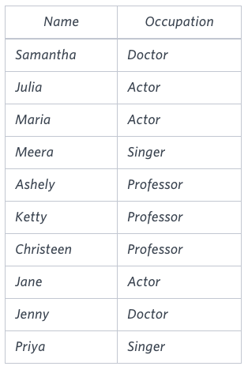
Sample Output
Jenny Ashley Meera Jane
Samantha Christeen Priya Julia
NULL Ketty NULL Maria

Explanation
The first column is an alphabetically ordered list of Doctor names.
The second column is an alphabetically ordered list of Professor names.
The third column is an alphabetically ordered list of Singer names.
The fourth column is an alphabetically ordered list of Actor names.
The empty cell data for columns with less than the maximum number of names per occupation (in this case, the Professor and Actor columns) are filled with NULL values.
ANS:-
SET @d=0,@a=0,@p=0,@s=0;
SELECT MIN(Doctor),MIN(Professor),MIN(SINGER),MIN(Actor) FROM(
SELECT IF(OCCUPATION='Actor',NAME,NULL) AS Actor,
IF(OCCUPATION='Doctor',NAME,NULL) AS Doctor,
IF(OCCUPATION='Professor',NAME,NULL) AS Professor,
IF(OCCUPATION='Singer',NAME,NULL) AS SINGER,
case OCCUPATION
when 'ACTOR' THEN @a:=@a+1
when 'Doctor' THEN @d:=@d+1
when 'Professor' THEN @p:=@p+1
when 'Singer' THEN @s:=@s+1
end as idn
FROM OCCUPATIONS ORDER BY NAME ) AS TMP GROUP BY TMP.idn ;
4.You are given a table, BST, containing two columns: N and P, where N represents the value of a node in Binary Tree, and P is the parent of N.
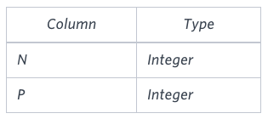
Write a query to find the node type of Binary Tree ordered by the value of the node. Output one of the following for each node:
- Root: If node is root node.
- Leaf: If node is leaf node.
- Inner: If node is neither root nor leaf node.
Sample Input
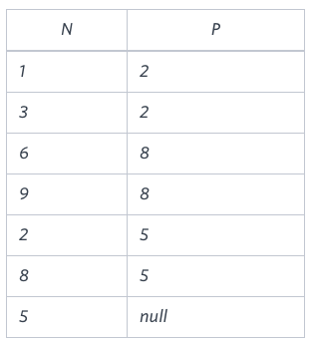
Sample Output
1 Leaf
2 Inner
3 Leaf
5 Root
6 Leaf
8 Inner
9 Leaf

Explanation
The Binary Tree below illustrates the sample:
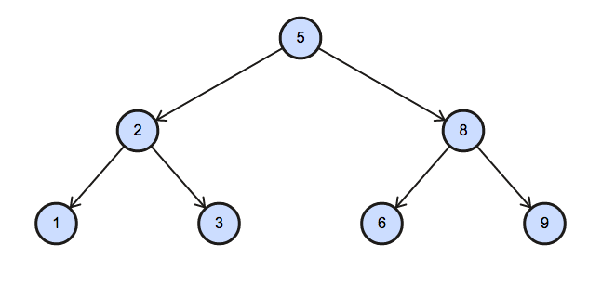
ANS:-
SELECT N ,
CASE
WHEN P is null then 'Root'
WHEN N in (SELECT P FROM BST) THEN "Inner"
ELSE "Leaf"
END
FROM BST
ORDER BY N;
5.Amber's conglomerate corporation just acquired some new companies. Each of the companies follows this hierarchy: 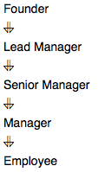
Given the table schemas below, write a query to print the company_code, founder name, total number of lead managers, total number of senior managers, total number of managers, and total number of employees. Order your output by ascending company_code.
Note:
- The tables may contain duplicate records.
- The company_code is string, so the sorting should not be numeric. For example, if the company_codes are C_1, C_2, and C_10, then the ascending company_codes will be C_1, C_10, and C_2.

Input Format
The following tables contain company data:
- Company: The company_code is the code of the company and founder is the founder of the company. 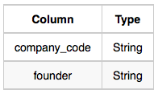
- Lead_Manager: The lead_manager_code is the code of the lead manager, and the company_code is the code of the working company. 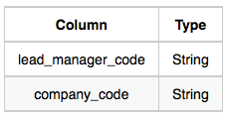
- Senior_Manager: The senior_manager_code is the code of the senior manager, the lead_manager_code is the code of its lead manager, and the company_code is the code of the working company. 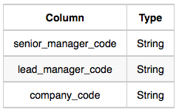
- Manager: The manager_code is the code of the manager, the senior_manager_code is the code of its senior manager, the lead_manager_code is the code of its lead manager, and the company_code is the code of the working company. 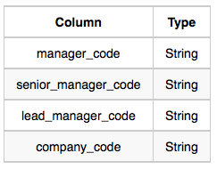
- Employee: The employee_code is the code of the employee, the manager_code is the code of its manager, the senior_manager_code is the code of its senior manager, the lead_manager_code is the code of its lead manager, and the company_code is the code of the working company. 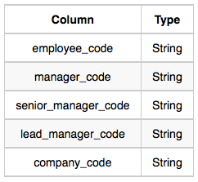

Sample Input
Company Table: 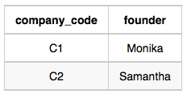 Lead_Manager Table: 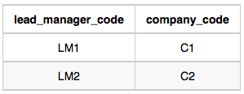 Senior_Manager Table: 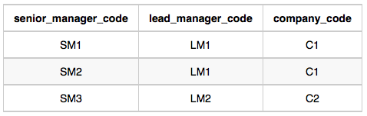 Manager Table: 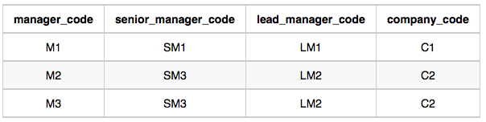 Employee Table: 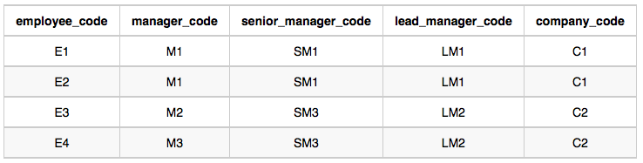
Sample Output
C1 Monika 1 2 1 2
C2 Samantha 1 1 2 2

Explanation
In company C1, the only lead manager is LM1. There are two senior managers, SM1 and SM2, under LM1. There is one manager, M1, under senior manager SM1. There are two employees, E1 and E2, under manager M1.
In company C2, the only lead manager is LM2. There is one senior manager, SM3, under LM2. There are two managers, M2 and M3, under senior manager SM3. There is one employee, E3, under manager M2, and another employee, E4, under manager, M3.
ANS:-
SELECT c.COMPANY_CODE,c.FOUNDER,
COUNT(distinct e.lead_manager_code),
COUNT(distinct e.senior_manager_code),
COUNT(distinct e.manager_code),
COUNT(distinct e.employee_code)
FROM Employee e ,company c
WHERE c.company_code = e.company_code
group by c.company_code,c.founder
order by c.company_code;
AGGREGATION
1

